Heart of Sound Affiliate Partner Resources

Online Teacher Training

Thanks for your support of Heart of Sound!

This document includes all that you need to begin promoting our programs and trainings as an affiliate partner. In it, you’ll find some suggestions for promotional copy to get you started, as well as images you can use.

We've made it simple; all you have to do is copy, paste and send, or post on your favorite social media platform. Of course, you're free to edit or add your own personal voice to the emails and posts. Or write one of your own!

IMPORTANT: Be sure to replace anything in [RED] with your own information, and to grab your personalized affiliate links from the Affiliate Dashboard. Remember, you MUST use your custom affiliate links so we can keep track of your referrals and pay out your bonuses. If you don’t use the links, you won’t get proper credit.
Have questions? Need help? Email Therese, our HOS Affiliate Community Manager, at heartofsoundaffiliates@gmail.com and we’ll get back to you right away!

Have fun!

_____________________________________________________

SAMPLE EMAIL PROMOTION

Subject Line Options (choose one):
- The Best Teacher Training to Learn the Yoga of Sound
- Love mantra & kīrtan? Next-level skills and chant leadership techniques
- LOVE chanting? Uplevel your skills in the world’s first (and best!) Sound-based Yoga teacher training!

Sample Email Copy (Long)

Dear [First Name],

I’ve got great news for you, my chant-loving, sound-curious friends!

One of my beloved mentors, Anandra George – you’ve probably heard me rave about her – is opening her Heart of Sound online teacher training courses to the public for the first time!

I am so happy to turn you on to a way of approaching mantra and sound with the power to change your life in so many tangible and intangible ways.

Anandra is an internationally respected Sanskrit mantra teacher and musician. She is a pioneer in the global yoga community and is well known for her work reintroducing the transformational power of sound as a fundamental wellbeing practice. Her teacher trainings get rave reviews, and she and the Heart of Sound teaching team are offering a wealth of online courses!

If you’ve chanted with me, you’ve already benefited from the Heart of Sound… now you have the opportunity to experience it for yourself. Whether you just try out one of her free introductory gifts, or especially if you join one of the deep-dive, teacher-training level courses, I predict you’ll thank me later!

Browse courses now. < [EMBED UNIQUE AFFILIATE LINK FOR COURSES PAGE HERE]

Here are some of my favorites:
- The 200hr Teacher Training is the GOLD. The new online format offers a rich mix of LIVE practices and pre-recorded material for you to geek out on! And you can join from anywhere!
- The Sacred Sanskrit Sounds course will change your mantra practice… forever.
- The Nāda Yoga course will open your voice and melt your heart with the love from 3 generations of Hindustanī classical vocalists (Anandra, her guru brother Sudhanshu, and their Guruji Pandit Baldev Raj Verma)
- Plus the new Mentorship circles and the 300/500hr Advanced Training look amazing too!
Let me know if you’d like to hear more from me about my experiences with the Heart of Sound trainings. The team is always happy to answer questions, and Anandra is doing several informal “Chai Times” this month on Zoom that you can hop on, too.
Enjoy!
With love,
[Your name]

P.S. In case you missed it, check it out here [<--EMBED UNIQUE AFFILIATE LINK TO HOME PAGE HERE]

Email Copy (Short)

Dear [first name]

I’ll make this quick. I've got some amazing news for you, my chant-loving, sound-curious friends!

One of my beloved mentors, Anandra George – you’ve probably heard me rave about her – is opening her Heart of Sound online teacher training courses to the public for the first time!

Honestly, the 200 hour Online Teacher training is gold! The new online format offers a rich mix of LIVE practices and pre-recorded material for you to geek out on! And you can join from anywhere!

Check it out here:

[Insert your Affiliate Link to TT program here]

Trust me. It will rock your world!

Plus, Anandra is the real deal – an internationally respected Sanskrit mantra teacher, musician and pioneer in the global yoga community. She’s recognized all over the world for her work reintroducing the transformational power of sound as a fundamental wellbeing practice.

This is an awesome opportunity to train with her personally!

Whether you just try out one of her free introductory gifts, or especially if you join one of the deep-dive, teacher-training level courses – including the brand new 500 hour option – you’ll thank me later!

Learn more here [<--EMBED UNIQUE AFFILIATE COURSE PAGE LINK HERE]
Enjoy!
With love,
[Your name]

P.S. In case you missed it, check it out here [<--EMBED UNIQUE AFFILIATE HOME PAGE LINK HERE]

Sample Facebook & Instagram Posts

OPTION - SHORT & SWEET WITH EMOJIS
💓 LOVE chanting?
🎵 Fascinated by the power of sound?
🤓 Want to uplevel your sanskrit mantra, harmonium, and chant leading skills?

You owe it to yourself to explore the wealth of online teacher training level courses offered by the Heart of Sound! (And plenty of FREE courses too!)

I highly recommend diving in: [YOUR UNIQUE AFFILIATE LINK HERE]

#heartofsound
@heartofsound.in

OPTION - FEEL THE POWER OF LOVE

💖 Are you ready to feel the awesome power of LOVE through sacred sound? 💖

The Heart of Sound training helped me to explore the resonance of my
unique voice, and use sound and mantra more skillfully for my own resilience and mental digestion. My practice has been my lifeline in tough times! And I can feel my increased capacity to feel, to embrace, to be an instrument of love, reverberating into the world around me.

If you already love chanting, kīrtan, or Sanskrit mantra and want to deepen your practice, I highly recommend you check it out:
[YOUR UNIQUE AFFILIATE LINK HERE]

Especially if you’re already singing, chanting, or teaching Sanskrit mantras publicly, the teacher training training will rock you world!
You’ll thank me later. ;) [YOUR UNIQUE AFFILIATE LINK HERE]

#heartofsound
@heartofsound.in

OPTION - BLOWN AWAY BY ONLINE LEARNING TESTIMONIAL
😮 I’m in awe of all the extensive material in the Heart of Sound online portal!!
I was blown away during the teacher training in India last year, but this takes learning to a whole new level! Not only can I pause, repeat, and integrate at my own pace, there is SO MUCH more detail that I'm sure we didn't cover in person.”
-Hamsadevi, Australia

💓 LOVE chanting?
🎵 Fascinated by the power of sound?
🤓 Want to uplevel your skills?

You owe it to yourself to explore the wealth of online teacher training level courses offered by the Heart of Sound! (And plenty of FREE courses too!)

I highly recommend diving in: [YOUR UNIQUE AFFILIATE LINK HERE]

#heartofsound
@heartofsound.in

OPTION - LIFE-CHANGING TESTIMONIAL
"It was such a life-changing moment when I realized this training is everything I could have wished for (and then some 😁)! I have really found it to work surprisingly well online. The practice has already changed my life in such deep ways, and I have no doubt that it will continue unfolding in both my internal and external life. I can't wait to share the therapeutic power of sound with my clients."
-Avilou, Denmark

💓 LOVE chanting?
🎵 Fascinated by the power of sound?
🤓 Want to uplevel your skills?

You owe it to yourself to explore the wealth of online teacher training level courses offered by the Heart of Sound! (And plenty of FREE courses too!)

I highly recommend diving in: [YOUR UNIQUE AFFILIATE LINK HERE]

#heartofsound
@heartofsound.in

OPTION - TUNING SANSKRIT TESTIMONIAL
Anandra ruined me. My chant practice has never been the same!
😉 (In a GOOD way!) 😉

Since learning her one-of-a-kind Tantrik approach to the Sanskrit sounds, I can taste the bliss of my mantra practice in a way I never before dreamed was possible.

If you love mantra or kīrtan, and have never learned how to chant the Sanskrit alphabet or pronounce mantras correctly I guarantee you’ll FALL IN LOVE with her passionate, nerdy style of sharing what she loves:
The transformational power of sound and mantra!

If you enjoy an embodied direct experience (rather than a dry, intellectual approach)...
If you sense your mantra & kīrtan practice is just scratching the surface of its divine potential…
If you care about not perpetuating the cultural appropriation yuck that’s ubiquitous in the yoga/spiritual/wellness world...

Seriously, you owe it to yourself to explore the wealth of online teacher training level courses offered by the Heart of Sound! (And plenty of FREE courses too!)

I highly recommend diving in: [YOUR UNIQUE AFFILIATE LINK HERE]

#heartofsound
@heartofsound.in

ADDITIONAL HASHTAG SUGGESTIONS:

#musicismedicine
#sacredsound
#chantyourheartopen
#ecstaticchant
#sacredmusic
#soundyoga
#soundyogaschool
#soundhealing
#musiclife
#musictherapy
#soundhealing
#vibration
#vibrationalhealing
#thrivelife
#fulfilled
#uplift
#thriving
#resilient
#goodvibes
#empathy
#connection
#heartofsound

---------------

Images

Anandra

Anandra & Tanpura with Logo
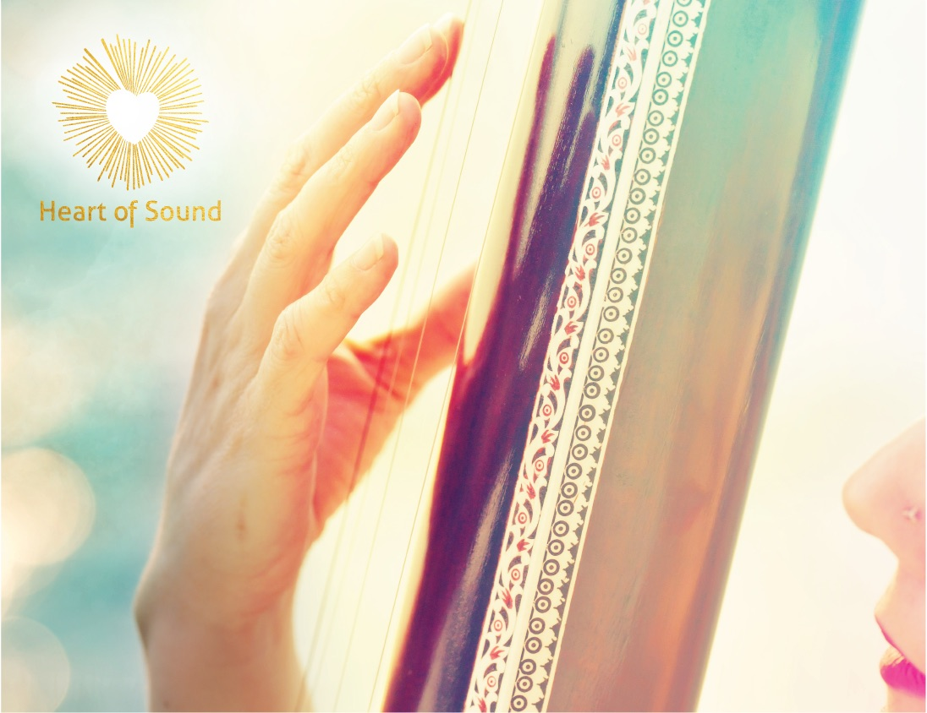

ZOOM Online Group Practice screenshot with logo
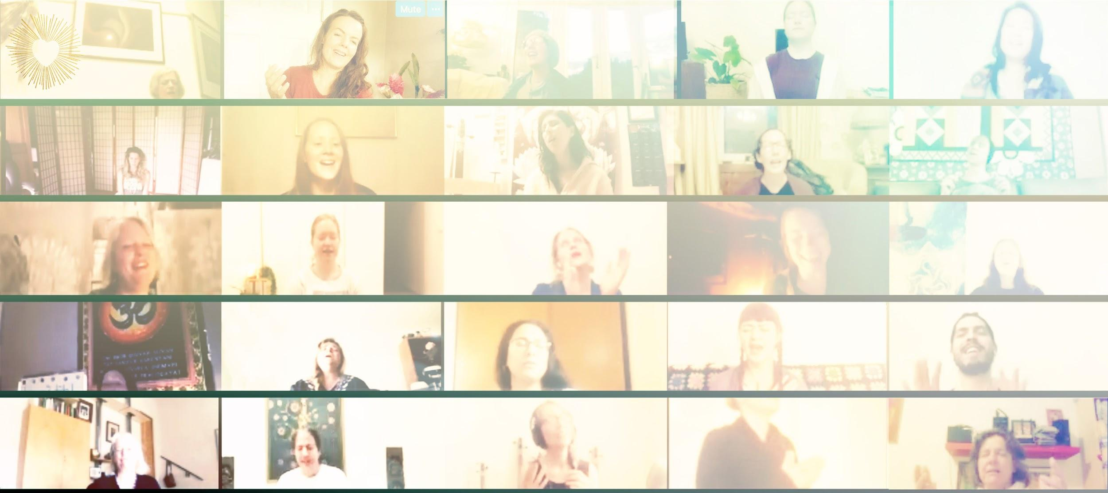

Image with Logo and URL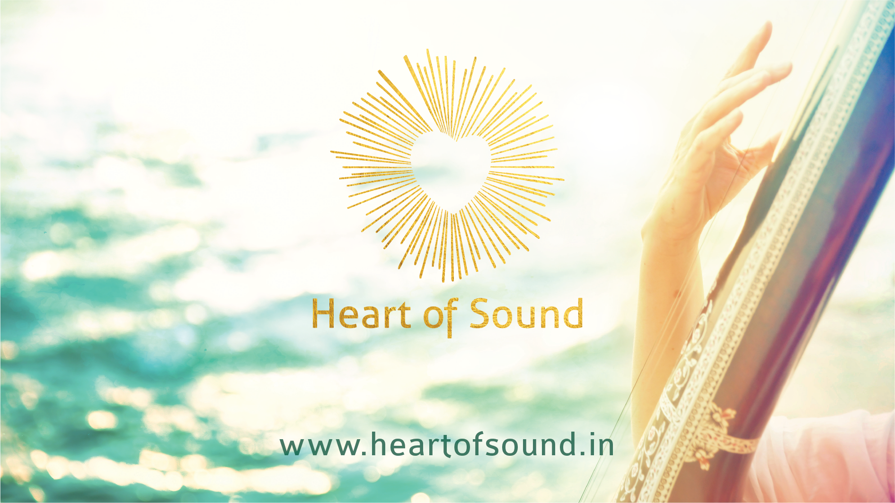

Nāda Yoga course main image:

Sacred Sanskrit Sounds course main image:

Harmonium and Roses

Outdoor Computer w/Actual Course Lesson on screen

Person Accessing Course on iPhone

