Heart of Sound Affiliate Partner Resources

Free Online Event

Thanks for your support of Heart of Sound!

This document includes all that you need to begin promoting the upcoming free online event as an affiliate partner. This is free, juicy chant experience, and it’s a great introduction to the Heart of Sound.

Plus, your tracking link stays attached for 30 days. That means that if any of your leads purchase any eligible product during that time, you'll earn a referral bonus!

We've made it simple. Below, you’ll find some suggestions for promotional copy to get you started, as well as images you can use. All you have to do is copy, paste and send, or post on your favorite social media platform. Of course, you're free to edit or add your own personal voice to the emails and posts. Or write one of your own!

IMPORTANT: Be sure to replace anything in [RED] with your own information, and to grab your personalized affiliate links from the Affiliate Dashboard. Remember, you MUST use your custom affiliate links so we can keep track of your referrals and pay out your bonuses. If you don’t use the links, you won’t get proper credit.

Have questions? Need help? Email Therese, our HOS Affiliate Community Manager, at heartofsoundaffiliates@gmail.com and we’ll get back to you right away!

Have fun!

________________________

SAMPLE EMAIL PROMOTION

Subject Line Options (choose one or create your own):

- [FREE CLASS] Experience the Yoga of Sound
- Chant Your Heart Open, Nourished, and Resilient
- Need empathy, resilience, soul nourishment? Experience the Heart of Sound
- LOVE Chanting? Refine your Sanskrit & Sing your Heart Open!

Email Long Copy (sample)
Dear [first name],

Have I gushed to you about my profound experiences with the Heart of Sound? I’m pretty sure I have. It’s an incredible approach to mantra and sound that will change your life in so many tangible and intangible ways.

And I can’t wait to share it with you. My friend and teacher Anandra George is offering a free online chant experience that I’m really excited about. If you love chanting… are curious about the power of sound… or want to uplevel your skills, you won’t want to miss it.

It’s happening online on WEDNESDAY, NOVEMBER 11, and it’s absolutely free. It’s by reservation only though, and takes about 10-15 mins of prep time, so you need to sign up [embed your affiliate link here] now to reserve your spot.

In this 1-hour chant experience, you’ll:
- Connect with a global community in a sound-based practice designed to nourish, regenerate, and cultivate resilience.
- Learn how to use sound and mantra to strengthen your capacity for listening, empathy, and peacemaking with your loved ones and greater community.
- Experience the benefits of a sound-based practice for subtle body hygiene so you can more gracefully digest what life is serving up for you right now.
- Find your authentic voice and maximal personal resonance with a vocal coaching practice. Warning: Don’t do this if you don’t want to FALL IN LOVE with your own voice!
- Taste the sweet nuance of more refined Sanskrit mantra pronunciation on your palate, and in your body.
- Learn a paradigm-shifting mindset to awaken your inner musician and tap into the creative, authentic joyspring of your soul expression. (it’s fruitful for seasoned performers and non-musicians alike!).
If all that sounds too good to be true, I can assure you it’s not.
If you sign up, prepare your space, and join the chant experience with an open mind and heart, you might just experience the deep transformational power of sound for yourself.

Anandra is an internationally respected Sanskrit mantra teacher, musician and pioneer in the global yoga community. She’s well-known for her work reintroducing the transformational power of sound as a fundamental wellbeing practice and I’m honored to call her my friend and mentor.

Will you join us on Saturday to experience the magic? I hope so.

Here’s the RSVP link again [embed your unique affiliate link here]
With love,
[Your name]

P.S. You'll have the chance to ask Anandra questions at the end of the live experience. Go here to reserve your spot for free. [<--EMBED UNIQUE AFFILIATE LINK HERE]

Email Copy (Short)

Dear [first name]

I’ll make this quick. I've got some amazing news for you, my chant-loving, sound-curious friends!

One of my beloved mentors, Anandra George – you’ve probably heard me rave about her – is offering a free online chant experience that I’m really excited about. If you love chanting… are curious about the power of sound… or want to uplevel your skills, you won’t want to miss it.

Check it out here:

[Insert your Affiliate Link to FREE WEBINAR program here]

Trust me. It’ll be delicious.

Plus, Anandra is the real deal – an internationally respected Sanskrit mantra teacher, musician and pioneer in the global yoga community. She’s recognized all over the world for her work reintroducing the transformational power of sound as a fundamental wellbeing practice.

This is an awesome opportunity to hear directly from her, and experience mantra and sound in a whole new way!

If you sign up, prepare your space (you’ll need about 10-15 to get ready), and join the chant experience with an open mind and heart, you might just experience the deep transformational power of sound for yourself.

Learn more here [<--EMBED UNIQUE AFFILIATE COURSE PAGE LINK HERE]
Enjoy!
With love,
[Your name]

P.S. Warning: Don’t do this if you don’t want to FALL IN LOVE with your own voice!

Seriously, check it out here [<--EMBED UNIQUE AFFILIATE HOME PAGE LINK HERE]

The event will be live online via Zoom and it’s totally free. But space is limited and you won’t get in without a reservation. So sign up now. You can thank me later.

I’ll see you online!

Social Media Samples (FB & Instagram)

OPTION 1 - CHANT YOUR HEART OPEN 💓
Chant your heart open, nourished, and resilient with my dear friend and teacher Anandra George. She’s offering a special free Yoga of Sound experience designed for leaning in to the transformational power of sound. Come chant with our global community and fill your tank with great vibes, deep empathy, and juicy embodied connection. I highly recommend reserving your place now: [YOUR UNIQUE AFFILIATE LINK HERE]

#heartofsound
@heartofsound.in

OPTION 2 - FUNNY ;) HYGIENE
Too much news got you overwhelmed? Pandemic-related uncertainties stressing you out? 😯 You might need some “Subtle Body Hygiene!” 💩🤣
For real tho… you’ve got a chance to learn yoga of sound practices for heart/mind/body digestion of what life is serving up for you right now on a special free chant experience with my dear friend and teacher Anandra George. I highly recommend reserving your place now: [YOUR UNIQUE AFFILIATE LINK HERE]

#heartofsound
@heartofsound.in

OPTION 3 - EMPATHY
🏋🏽 Are your empathy muscles getting a workout these days? 🏋🏽
Mine sure are! My dear friend and teacher Anandra is offering a free Yoga of Sound experience teaching how to use sound and mantra to strengthen your capacity for listening, empathy, and peacemaking with your loved ones and greater community. I highly recommend reserving your place now: [YOUR UNIQUE AFFILIATE LINK HERE]

OPTION 4 - SHORT CHANT EXPERIENCE

Love chanting? Curious about the power of sound? Want to uplevel your skills? Learn more about creating, enlivening, and refining your sound-based practice with internationally respected Sanskrit mantra teacher and musician Anandra George.

I highly recommend diving in: [YOUR UNIQUE AFFILIATE LINK HERE]

#heartofsound
@heartofsound.in

OPTION 5 - SHORT & SWEET WITH EMOJIS
💓 LOVE chanting? Or just curious?
🎵 Fascinated by the power of sound?
🤓 Want to uplevel your sanskrit mantra, and chant leading skills?

Come explore the Yoga of Sound with the amazing Anandra George. It’s free, it’s online, and we’re saving a spot for you.

RSVP NOW: [YOUR UNIQUE AFFILIATE LINK HERE]

#heartofsound
@heartofsound.in

ADDITIONAL SUGGESTED HASHTAGS

#musicismedicine
#sacredsound
#chantyourheartopen
#ecstaticchant
#sacredmusic
#soundyoga
#soundyogaschool
#soundhealing
#musiclife
#musictherapy
#soundhealing
#vibration
#vibrationalhealing
#thrivelife
#fulfilled
#uplift
#thriving
#resilient
#goodvibes
#empathy
#connection
#heartofsound

---------------

Images

Anandra
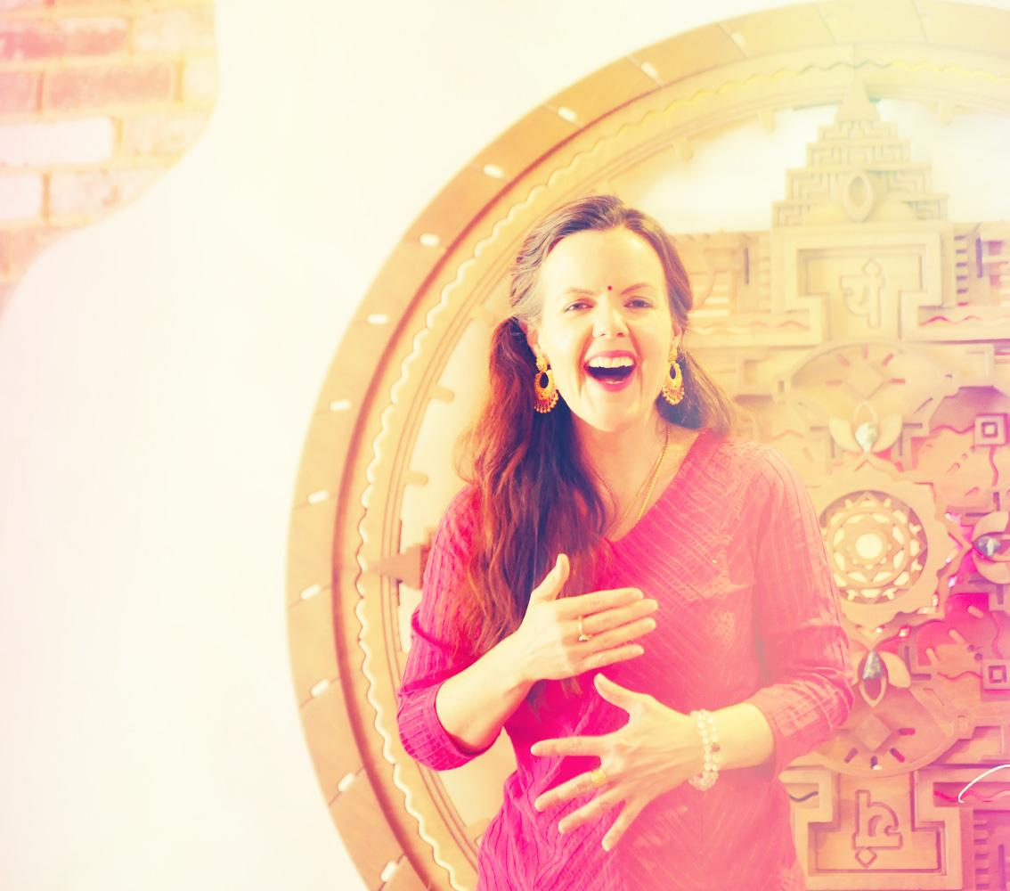

With Logo Postcard with Anandra & Tanpura
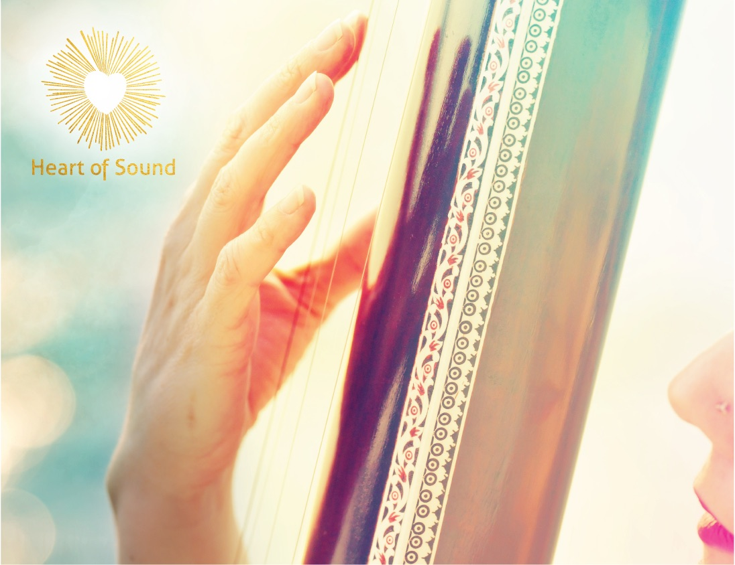

ZOOM Online Group Practice screenshot with logo
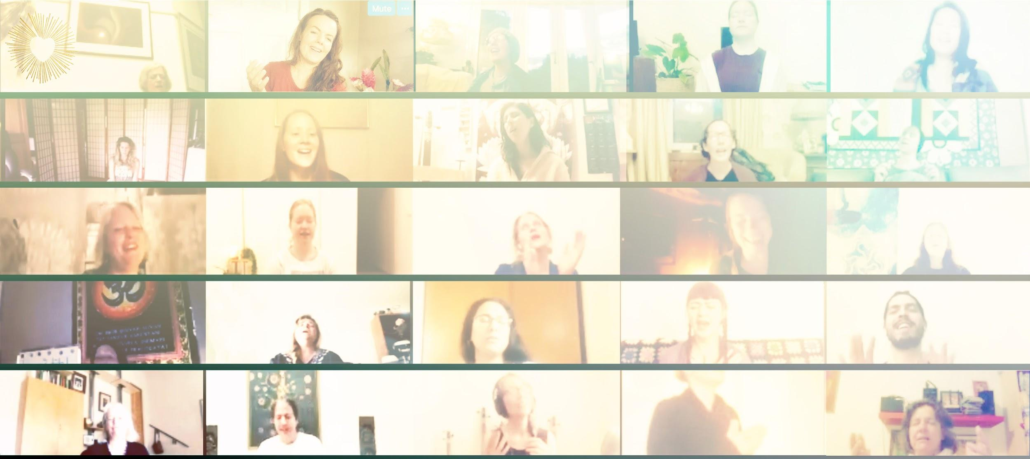

Homepage Hero Image with Logo and URL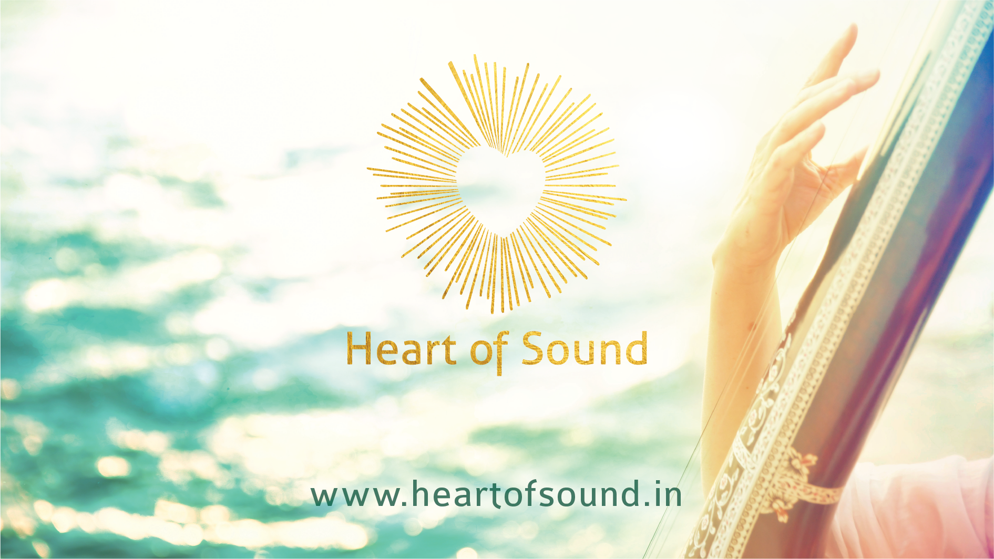

Nāda Yoga course main image:

Sacred Sanskrit Sounds course main image:

Harmonium and Roses

Outdoor Computer w/Actual Course Lesson on screen

Person Accessing Course on iPhone

